**Sohal Patel**

**CIS 410**

**9/15/2020**

**APPEX CORPORATION SERVICES – Case Obligation**

APPEX CORPORATION SERVICES is an organization which provides ample customer relationship services, payment transaction, and various inner and outer information technology communication and manipulation services as a whole to various cellular networking companies. Following a strategy of innovation is based on providing efficiency and effectiveness for the end-users e.g. clients of the APPEX Corporation services.

The case organization grew popular amongst the industry due to the capability of the systems rendered by the APPEX corporation services. Moreover, the major task which is ensured by the APPEX corporation services is to develop a transactional inter-system for these cellular networking companies which could be devised to bill the customer e.g. end-user appropriately and automatically as per the dire charges for the services depending on the cellular networking companies.

APPEX corporation services as an organization are known to be as dynamic, it has devised a foothold strategy amongst the pertaining industry; which leads the employees e.g. professionals of the APPEX corporation services to promulgate dire problem solving and promulgate the tasks with efficacy and innovation in a holistic approach. In a nutshell, this approach renders an acquisition for APPEX corporation services in such a way that all employees e.g. professionals of APPEX corporation services have no fixed roles, responsibilities, or classifications. They could be deemed as per their nature and type of tasks to be congregated over this manifestation.

Therefore, this strategy results in providing flexibility over the tasks of the APPEX corporation service. Thus, the dynamic structure retains an advantage for its end-users, but as per this case of APPEX corporation service; an organization having only 25 employees, it resulted in causing damage to the APPEX corporation services as the market opponents induced various strategies to improvise their organization structure.

Whereas, the APPEX corporation services lacked at having any structure for their organization which led to various issues such that drawback of congregating financial planning. Lest, the customers of APPEX corporation services were treated in “I’ll Call You Back” manifestation, which resulted in causing damage to the market reputation of APPEX as an organization.

To cope with the issues being faced by the APPEX corporation services; they hired a new COO e.g. Chief Operational Officer named Shankar Ghosh. This professional was hired because he has in-depth knowledge about the organizational structure.

Thus, he belonged from Boston Consulting Company and was aimed to solve the issues facing by the APPEX. Therefore, he noticed that the issues faced by the APPEX e.g. the financial planning, customer relationship, and services provided by APPEX need a dire structure to manipulate all of these tasks.

As per the threshold of this approach, the hindsight of all the issues and vulnerabilities being faced by the APPEX corporation services, Mr. Shankar Ghosh decided to become the Chief Executive Officer (CEO) e.g. he is in-charge of all of the tasks of APPEX corporation services.

Firstly, for the revolution of the APPEX corporation services, Mr. Shankar Ghosh decided to apply the circular organizational structure. Over this approach, all the roles and responsibilities have to report a single authority.

Following this approach lead Mr. Shankar Ghosh to detect the shortcomings of the APPEX corporation services as soon as possible as this structure was applied but the previous employees of the APPEX Corporation Services cannot adjust themselves with this structure, for issues prevailing Mr. Shankar Ghosh again tried to change the organizational structure.

Following up on this situation, Mr. Shankar Ghosh tried to change the organizational structure from a circular structure to a horizontal structure. Whereas, for Mr. Shankar Ghosh this structure was also ample to congregate the shortcomings faced by the APPEX corporation services, but the previous 25 employees cannot obligate with this structure also.

Mr. Shankar Ghosh made new recruitments but somehow this innovative model also didn’t suit the previous and new employees of the APPEX corporation services

Therefore, Mr. Shankar Ghosh noticed that the innovative organizational structure cannot be followed up as a whole for APPEX corporation services.

So, Mr. Shankar Ghosh tried to follow up on the traditional techniques for the manipulation of tasks and mitigating the vulnerability of financial planning and lack of customer relationship formation.

But the after consequences of applying traditional techniques; such that Mr. Shankar Ghosh rendered to the development of teams as the case happened of the APPEX corporation services. Every employee and professional of APPEX corporation services starting to form teams to forge the company’s policy and tried to cause more damage to the financial planning of the APPEX corporation services.

Whereas, the employees e.g. both newly and previously recruited were centralized to cause impulsive damage to the market reputation of APPEX corporation services. Therefore, Mr. Shankar Ghosh was rendering to an acquisition that how he could result in mitigating this vulnerability being faced by the APPEX corporation services in a holistic approach.

Even if Mr. Shankar Ghosh tried to make the incremental changes but the vulnerability across the systemization of APPEX corporation services persisted. Though Mr. Shankar Ghosh tried to apply EDS organizational structure the obligation rendered that the authorities should themselves try to find a possible solution for the APPEX corporation services as a whole.

For devising a solution for the case organization e.g. APPEX; we’d conduct a complete Industry competitive analysis to overlook the current situation. As it is already initiated that APPEX provides intermediate services in between the various cellular companies and their customers as a whole.

The reason for which the APPEX corporation services succumb at the start of their market structure was due to its innovative structure and the services it provides to the customers.

But a market opponent of the APPEX corporation services, known as ATC follows a similar service’s but firstly they focused on the development of an organizational structure for themselves and followed a complete strategy to induce in the market notion. Whereas, the case organization lacked at following any strategy at the start of their market career.

Now we could apply the FIVE porter services to know the actual market position of the APPEX Corporation services across the market competitors of the case organization. Therefore, the APPEX corporation services had the advantage to be a frontrunner in the promulgation of the tasks but the actual reason for the drawback or the shortcomings of the case organization. It led to an impulsive drawback because the threat of market competitors lead to impulsive damage for the case organization. Focusing on the FIVE porter services over this case, the pictorial manifestation of this case could be rendered as, (GOLD RATT, 2004) (PORTER, 20 MAY 2015)

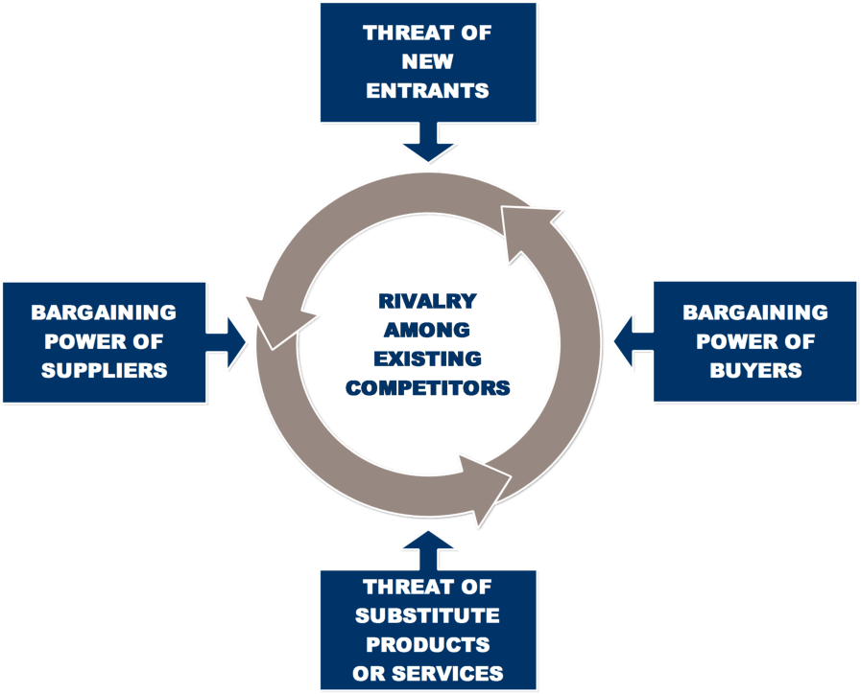

Figure 1- FIVE PORTER FORCES (FOLEY, 2015)

The porter forces to be induced for the case organization is:

1. The threat of new entrants on APPEX
2. Bargaining power of customers on APPEX
3. The threat of substitute product of services of APPEX
4. Bargaining power of suppliers on APPEX

To conclude the solution of this approach in a holistic approach, the case organization should train and aware of its employees and develop policies for all of the tasks. The policies include the BYOD policy, training overview policy, and operations management policy for the initial congregation of tasks.

The solution for the case organization for the organization is such that, they should induce EDS organizational structure by making the employees aware of their tasks force and the complex organizational structure of EDS centralizes to report a single authority. Whereas, Mr. Shankar Ghosh should himself try his best to involve as an authority and resign from the post of CEO. The integration of EDS along with APPEX should lead to congregate the tasks of APPEX corporation services.

To conclude the case obligation, it shows a case of the organization known as APPEX corporation services which should possibly be facing issues concerning their organizational structure. Mr. Shankar Ghosh applied many solutions to compensate for the problem but they noticed that innovational structure cannot be applied in any way to the APPEX, they applied traditional techniques but still faced impulsive issues to go-through the problem. An ICA is conducted for the organization.

The course of action selected for the case organization centralizes across implementing EDS organizational structure to the organization. The alternatives described were actually from EDS because from this framework every employee is made capable to congregate their tasks as a whole.

# References

FOLEY, P., 2015. FIVE PORTER FORCES. *FIVER PORTER FORCES*.

GOLD RATT, E. M. J. C., 2004. *THE GOAL, A PROCESS OF ONGOING IMPROVEMENT.* s.l., NORTH RIVER PRESS.

PORTER, M. E., 20 MAY 2015. HOW COMPETITIVE FORCES SHAPE STRATEGY. *HARVARD BUSINESS REVIEW,* pp. 1-3.

INTERNATIONAL, I. (2017). *The Evolution of ICA’s ToP Facilitation Methods.*

INTERNATIONAL, I. (2018). *ICA COMPLIANCE.* Los Angeles.

OMDIA. (2018). *ICA METHODOLOGY.*

ORIJA, E. (APRIL 1999). *INDEPENDENT COMPONENT ANALYSIS.*

PORTER. (2017). *PORTERS FIVE FRAMEWORKS.*

Skripak, I. A. (APRIL 2020). *DIGITAL VIRTUALIZATION TECHNOLOGIES IN DISTANCE LEARNING.*

ZHU, Y. (MAY 18TH 2018). *Application of ICA and Dynamic Mixture Model.*